Walchand College of Engineering, Sangli

Computer Science & Engineering

Third Year

Course: Design and analysis of algorithm Lab

Lab course coordinator:

Mrs A M Chimanna- Batch: - T1, T2, T3,T4

**Week 3 Assignment**

Part: 1

**Divide and conquer strategy**

**Q1)** Implement algorithm to Find the maximum element in an array which is first increasing and then decreasing, with Time Complexity *O(Logn).*

missing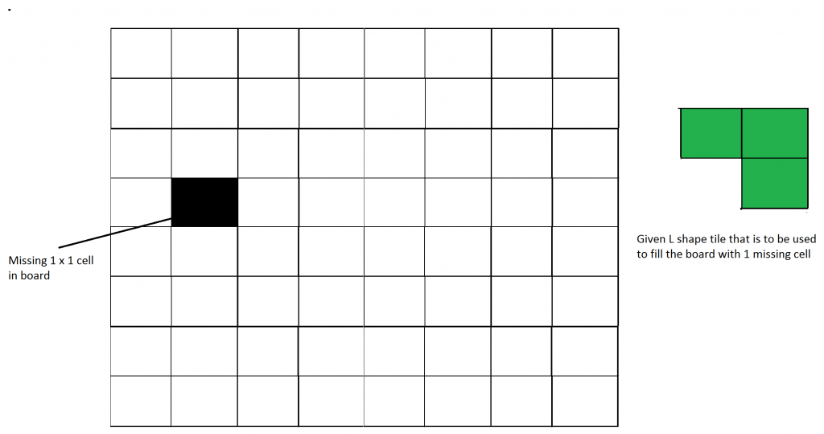

Q3) Implement algorithm for The Skyline Problem: Given n rectangular buildings in a 2-dimensional city, computes the skyline of these buildings, eliminating hidden lines. The main task is to view buildings from a side and remove all sections that are not visible.

All buildings share common bottom and every **building**is represented by triplet (left, ht, right)

‘left’: is x coordinated of left side (or wall).  
‘right': is x coordinate of right side  
‘ht': is height of building.

For example, the building on right side is represented as *(1, 11, 5)*

[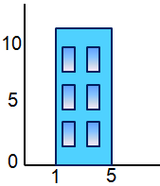](http://www.geeksforgeeks.org/divide-and-conquer-set-7-the-skyline-problem/building/)

A **skyline**is a collection of rectangular strips. A rectangular **strip**is represented as a pair (left, ht) where left is x coordinate of left side of strip and ht is height of strip.

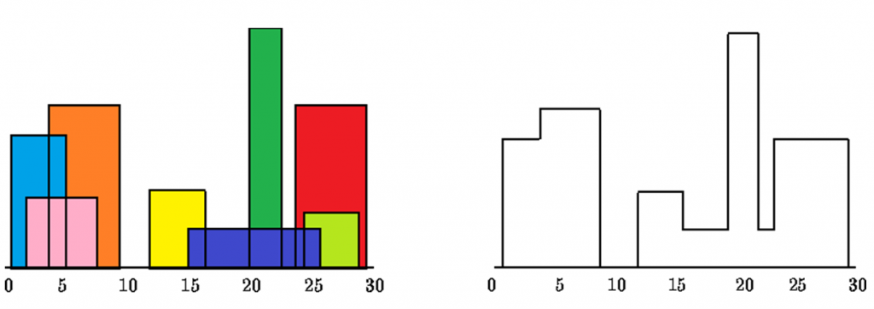

With Time Complexity *O(nLogn)*